NAOME 2021 Registration Form
2020 5th International Conference on Naval Architecture and Ocean&Marine Engineering
(NAOME 2021)
December 10-12, 2020丨Auckland, New Zealand丨www.icnaome.org
NOTE: Please send the required documents: 1. final paper(doc&pdf), 2. filled registration form, 3. Payment Voucher to naome@iased.org (Mail Subject: Paper ID+Registration).
- ATTENDEE INFORMATION

1-inch-Photo here
*Full Name:
*Position√: Prof. □  Assoc. Prof. □  Asst. Prof. □ Dr. □  Mr. □  Ms. □
*Affiliation:
*Nationality：_____________________
*Email: *Mobile Phone:
Emergency Contact(Name&Mobile):
Postal Address& Zip Code:
Catering Service(Dec.11)√: Lunch □ Dinner □
Special dietary√: Diabetic □ Vegetarian Halal food □ Other □ (please specify: )
Special requirements:
- PAPER INFORMATION
*Paper ID: *Paper Pages: *Additional Page:
*Paper Tile:
*Authors:
*Will you attend the conference Yes □ No □
*Presentation Type√: Oral □ Poster □ Remote Video □ Video □
Student ID No.(student only):
IASED Member No.(member only):
* Receipt Issued to:
- REGISTRATION FEE(by US dollar)
Category | Early  (Until Aug. 25) | Regular  (Until Oct. 5) | Late  (After Oct. 5) | On-site  (Dec. 10-12) | Online Presentation | Your choice
IASED Member  (Author) | USD 480 | USD 550 | USD 600 | USD 650 | USD 350
Nonmember  (Author) | USD 520 | USD 600 | USD 650 | USD 700 | USD 380
Student(Author) | USD 480 | USD 520 | USD 550 | USD 600 | USD 320
Presenter | USD 400 | USD 470 | USD 500 | USD 550 | USD 250
One day Program | USD 350 | USD 400 | USD 450 | USD 500 | USD 200
Social Networking Event | TBD
Academic Visit Optional | TBD

Extra Item | Cost | Your Choice
Extra Page/Per page | USD 70
Extra Paper Upload | USD 370
Extra Banquet Ticket | USD 70
*Notice
*Ordinary length limits is 5-10 pages per paper, If the paper exceeds 6 pages, the additional pages will be charged.
*All the papers will be published on-line.
*For "No shows", registration fee is nonrefundable.
*Cancellation policy: refund/cancellation requests must be submitted before 20 April, 2020, and the cancellation will incur US$100 administrative fee. After the date, the request will not be accepted.
*Bank charges and exchange commission will be borne by applicant.
*Our payment system will not charge any extra fee, but the credit card payment may incur few exchange commission which is charged by payers' bank, it should be borne by payers.
*One day program fee covers: Attend meeting session of Dec. 11 only to do presentation(not publish paper)+ coffee
breaks, lunch and dinner+ conference kits.
*Full registration fee covers :(Author only) publication fee + meeting sessions on Dec. 10-12 + 2 coffee breaks, 1 lunch, 1 dinner on Dec. 11 + conference kits.
- PAYMENT INFORMATION
URL of of official Online Payment System:
http://meeting.yizhifubj.com.cn/web/main.action?meetingId=351
* The system accepts VISA /Master for payment, please calculate the amount before payment.
Please fill your E-mail address used for payment and Confirmation Number you received after paying.
E-mail: | Confirmation Number:
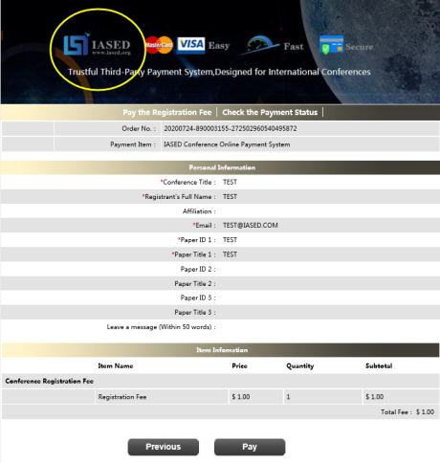
*Please make sure the conference organizer, IASED’s logo is always appear on the page until you click “ Pay”. Then you will be directed to payment page.
* As the system will intercept the email address for multiple payments, it is recommended to use different email for each payment
- IASED MEMBER APPLICATION
Join IASED now to enjoy the Member Registration Rate. Please compile and return the Membership Form along with your CV to membership@iased.org. Your application will be processed in 5 working days.
- OTHER
Finally, we suggest you write down a biographical sketch here, for use of making introductions by Session Chair before your presentation gets started.
20-120 Words(1-6.5 lines)

NAOME 2021 Conference Committee
Auckland, New Zealand

